Ex.No:1: Simulation of FDMA in MATLAB Date

Aim: To simulate a Frequency Division Multiple Access (FDMA) system using MATLAB
and analyze its communication performance in terms of channel bandwidth, data rate, and
signal-to-noise ratio (SNR).
Objective 1:
To simulate an FDMA system by allocating individual frequency channels to multiple users
and determine the channel bandwidth assigned to each user.
Output Parameter: Channel Bandwidth (kHz)
Objective 2:
To calculate the data rate achieved by each user in the FDMA system based on the allocated
channel bandwidth.
Output Parameter: Data Rate (kbps)
Objective 3:

To evaluate the communication quality of the FDMA system by calculating the Signal-to-
Noise Ratio (SNR) for different users.

Output Parameter: Signal-to-Noise Ratio (SNR) (dB)
Procedure
1. Open MATLAB and create a new script file.
2. Define the total available bandwidth, number of FDMA users, carrier frequencies, signal
power, and noise power.
3. Allocate a unique frequency channel to each user and calculate the channel bandwidth.
4. Compute the data rate for each user based on the allocated bandwidth and modulation
scheme.
5. Calculate the Signal-to-Noise Ratio (SNR) using the signal and noise power values.
6. Plot the transmitted signals of all FDMA users using different carrier frequencies.
7. Display the calculated channel bandwidth, data rate, and SNR in the MATLAB
Command Window.
8. Analyze the results to verify independent channel allocation and evaluate the overall
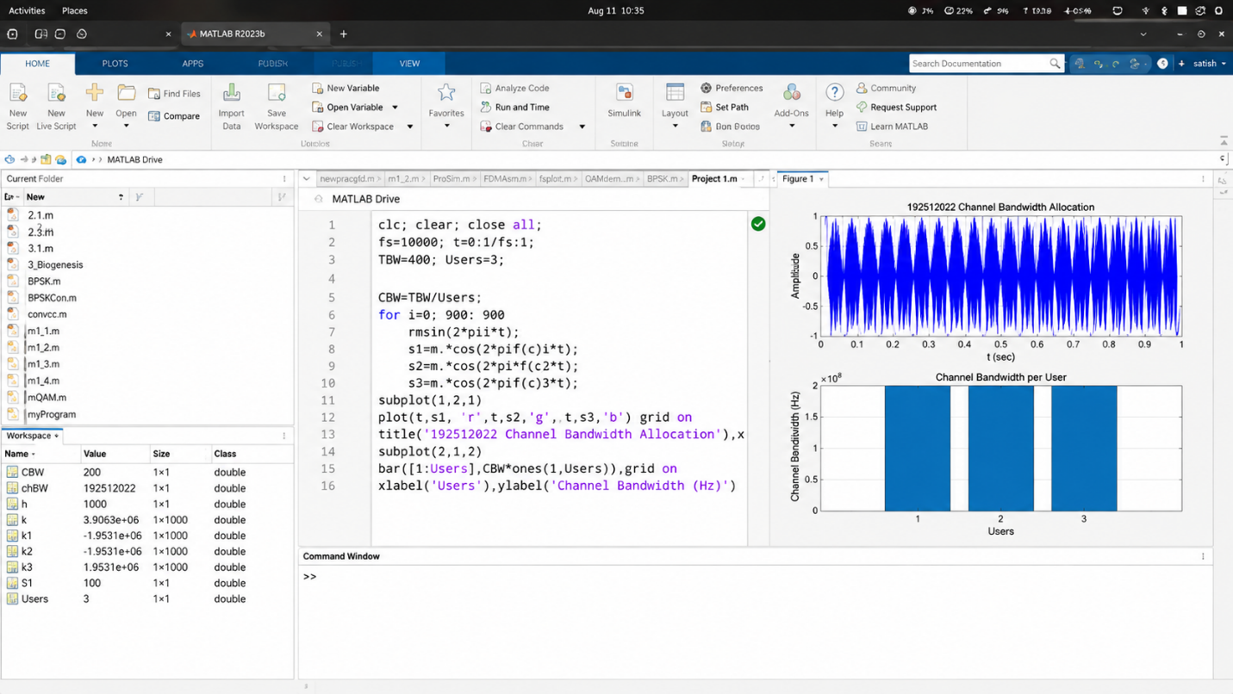
performance of the FDMA system.

